Application form
The NSW Department of Planning, Industry and Environment (DPIE) has opened Round 1 of the NSW Cigarette Butt Litter Prevention Grants Program with $500,000 of funding available to stakeholders as part of the eight-year $802 million Waste Less Recycle More initiative.
Applicants can apply for grants of up to $40,000 that target the reduction of cigarette butt litter and littering behaviour.
Grant applications close at 10am on Tuesday 28 July 2020

How to apply
Read the Information in these guidelines and apply using the form below. These documents and further information about the program can be accessed at epa.nsw.gov.au/your-environment/litter-and-illegal-dumping/epa-work-prevent-litter/reducing-cigarette-butt-litter.
Only one application can be submitted per applicant.
Check application is complete before submitting. You must have:
completed a Butt Litter Check
provided the signature of the land manager (i.e. council) that indicates support for the project
provide a signature of General Manager, CEO or appropriate organisational delegate to approve the application.
NOTE: If your application is successful, you will need to complete and deliver a work and safety plan identifying all potential health and safety risks and how you will manage those risks to ensure the safety of those participating in your project.
You can submit your application as an email attachment to litter.prevention@epa.nsw.gov.au with the subject line: ‘Your Organisation’s Name: Cigarette Butt Litter Prevention Grants Program Application’.

Need help?
If you need assistance with your application or have questions, contact the Litter Prevention Unit at litter.prevention@epa.nsw.gov.au.

Applicant details
Table 1 applicant details
Name of Organisation | Click or tap here to enter text.
ABN | Click or tap here to enter text.
Phone number | Click or tap here to enter text.
Email | Click or tap here to enter text.
Web address | Click or tap here to enter text.
Street address | Click or tap here to enter text.
Suburb | Click or tap here to enter text.
Postcode | Click or tap here to enter text.
State electorate | Click or tap here to enter text.

Project Manager (primary contact for grant application)
Table 2 project manager details
Project Manager Name | Click or tap here to enter text.
Organisation | Click or tap here to enter text.
Position title | Click or tap here to enter text.
Phone number | Click or tap here to enter text.
Mobile | Click or tap here to enter text.
Email | Click or tap here to enter text.
Street address | Click or tap here to enter text.
Suburb | Click or tap here to enter text.
Postcode | Click or tap here to enter text.
State electorate | Click or tap here to enter text.

Project overview
Table 3 project overview
Project Name | Click or tap here to enter text.
Total funding requested | $ (ex GST) - note maximum amount is $40,000  Click or tap here to enter text.
Project location and site type | List all project sites. Example:  - 13 Valentine Avenue, Parramatta: Office Block  - Parramatta Train Station: Valentine Ave: Train Station  Click or tap here to enter text.
Project reasoning | Describe how the information you collected with your Butt Litter Check(s), and any other research or data, underpins your project proposal. What has the research found? What is the litter problem? Where is the problem? Why is the litter occurring? (max 250 words)  Click or tap here to enter text.
Current binning rate across target sites | Please provide the current cigarette butt binning rate based on butt litter check results  Site 1: Click or tap here to enter text.  Site 2: Click or tap here to enter text.
Project target audience | Describe the key target audience(s) for your project site(s) and the identified litter type(s). For example, commuters, office workers on their break, pub patrons.  Click or tap here to enter text.
Project description | Provide a brief description of your project and how it will tackle the litter problem you have identified. What are you going to do to address the identified litter problem? (max 250 words)  Click or tap here to enter text.
Land manager/owner | Click or tap here to enter text.

Project objectives
Your project should target cigarette butt litter and littering behaviour. Projects should apply an integrated approach to litter prevention and establish broader objectives to ensure the project addresses a range of key outcomes relevant to improving smoker disposal behaviour.
These include:
cleaning
infrastructure
education and awareness
enforcement
ownership.
Considering what you have found through the Butt Litter Check and other research or data you have collected about littering behavior, complete the table below to outline your project objectives, targets and key performance indicators (KPIs).
Remember that objectives must be SMART (see Supporting Information below for more information). Examples are provided for your reference below.
Targets are deliverables within set timeframes that will aim to achieve the objectives through planned actions. Each objective must have at least one target.
Developing targets will also help identify the KPIs that will measure progress towards the targets and help measure success. Always consider how to measure success in achieving targets (e.g. data collection, community surveys) – targets should be measurable and cost effective.

What are the objectives, targets and KPIs of your project?
Table 4 project’s objectives, targets and KPIs
Overall objective | Targets | KPIs
What is the overall behavioral objective of your project?  Example: Increase cigarette butt binning rates at 13 Valentine Avenue, Parramatta. | What is the target for this objective?  Example: 50% increase in binning rates by end of project. | What will you use to measure progress and success?  Example: Butt Litter Check – pre and post observations.
Click or tap here to enter text. | Click or tap here to enter text. | Click or tap here to enter text.

Table 5 cleaning, targets and KPIs
Cleaning | Targets | KPIs
What is the primary cleaning objective of your project?  Example: undertake clean-up at hot spot to communicate expected behavior. | What is the target for this objective?  Example: Undertake two thorough clean-ups at Regents Park during the first quarter of the project. | What will you use to measure progress and success?  Example: site audit and fewer requests to Council to clean the site and a decrease in Council clean-up time measured through staff timesheets or reported hours.
Click or tap here to enter text. | Click or tap here to enter text. | Click or tap here to enter text.
Table 6 infrastructure, targets and KPIs
Infrastructure | Targets | KPIs
What is the primary infrastructure objective of your project?  Example: improve bin amenity at Regents Park. | What is the target for this objective?  Example: install four new butt bins at Regents Park by 30 November 2020. | What will you use to measure progress and success?  Example: site audit following installation.
Click or tap here to enter text. | Click or tap here to enter text. | Click or tap here to enter text.
Table 7 education and awareness, targets and KPIs
Education and awareness | Targets | KPIs
What is the primary education and awareness objective of your project?  Example: raise community awareness on the impact of cigarette butt littering. | What is the target for this objective?  Example: raise smokers’ awareness of the impacts of cigarette butts on the environment by 25%. | What will you use to measure progress and success?  Example: community surveys completed pre and post project to measure changes in attitudes over the life of the project.
Click or tap here to enter text. | Click or tap here to enter text. | Click or tap here to enter text.

Table 8 enforcement, targets and KPIs
Enforcement | Targets | KPIs
What is the primary regulation and enforcement objective of your project?  Example: increase community perception of being fined for littering cigarette butts and raise litter enforcement in LGA. | What is the target for this objective?  Example: a 20% increase in community awareness of litter fines by July 2020. | What will you use to measure progress and success?  Example: user surveys pre and post project.
Click or tap here to enter text. | Click or tap here to enter text. | Click or tap here to enter text.
Table 9 ownership, targets and KPIs
Ownership | Targets | KPIs
What is the primary ownership objective of your project?  Example: build smoker ownership of an area. | What is the target for this objective?  Example: 10% Increase in smoker pride in areas over life of the project. | What will you use to measure progress and success?  Example: Butt litter check user surveys.
Click or tap here to enter text. | Click or tap here to enter text. | Click or tap here to enter text.

Project plans
Describe the key activities and timings of your project. Timings do not need to be final, but rather provide an estimated schedule of your project delivery. Projects can start from September 2020 and must be finished by September 2021.
Ideally you should complete all steps in Stage 1 to help develop your project plan, before submitting your application. You may wish to revisit these steps at project inception once funding has improved to further refine your project.
Please note: brief examples have been provided below for guidance. Please provide more detailed actions and timings relevant to your target areas. Please refer to the EPA Guide to prevent cigarette butt littering for ideas and advice on developing your project.
Table 10 project plans
Step | Action | Month
Stage 1 Understand the problem
Step 1: Understand the target area | Example: Conduct initial site visit with project partners and key stakeholders  Note: You may wish to complete Steps 1,2, 3 on the same day  Click or tap here to enter text. | September 2020  Click or tap here to enter text.
Step 2: Consult and engage | Example: Meet with local council officer, cleansing teams and business owners to agree on project scope and involvement. Identify potential areas to establish a smoking zone.  Click or tap here to enter text. | September 2020  Click or tap here to enter text.
Step 3: Assess elements linked to butt littering | Example: Complete butt litter check (BLC) and identify drivers of littering behaviour.  Note: While you would have already completed a BLC before submitting your application, it is worth completing a follow up BLC prior to beginning your project.  Click or tap here to enter text. | September 2020  Click or tap here to enter text.
Step 4: Gather evidence | Example: Consult with local cleansing team, local businesses and council staff to further understand target site use. Undertake additional surveys of smokers at site to determine ideas for site improvements and suitable locations for a smoking zone.  Click or tap here to enter text. | September 2020  Click or tap here to enter text.
Step 5: Establish a smoking zone | Example: Set clear boundaries for smoking zone and reinforce with on-ground markings e.g. spray paint or floor stencils.  Note: Confirm smoking zone aligns with the Smoke-free Environment Act 2000 and the ‘4 metre law’. Confirm area aligns with stakeholder expectations and council regulations.  Click or tap here to enter text. | November – December 2020  Click or tap here to enter text.
Step 6: Install bins | - Order bins  - Install 4 x butt bins  - Review location and use and adjust accordingly  Note: Contact litter.prevention@epa.nsw.gov.au for a list of butt bin suppliers and specifications.  Click or tap here to enter text. | - October 2020  - December 2020  - February 2021  Click or tap here to enter text.
Step 7: Cleaning and infrastructure | Example: Council cleansing team to undertake initial thorough clean of target area, including cleaning all small litter items, butts; conduct spray clean and graffiti removal.  Install bench seat in smoking zone.  Click or tap here to enter text. | February 2021  Click or tap here to enter text.
Step 8: Direct smokers to smoking zone | Example: Install floor stencils at access points to target area directing smokers to butt bins  Note: Stencils designs can be found at litterlibrary.epa.nsw.gov.au/.  Click or tap here to enter text. | February 2021  Click or tap here to enter text.
Step 9: Build smoker ownership of area | Example: Install smoking sign stencil and chalk art to indicate area is for smokers  Click or tap here to enter text. | February 2021  Click or tap here to enter text.
Step 10: Education and social norming | Example: Display interpretive signs indicating impact of cigarette butt litter on environment. Establish a smoker champion who regularly uses the areas to encourage correct disposal for other smokers.  Click or tap here to enter text. | March 2021  Click or tap here to enter text.
Step 11: Enforcement | Example:  - Display floor stencils indicating litter fine amount  - Council rangers to conduct weekly patrols undertaking soft enforcement  - Councils rangers begin hard enforcement by issuing fines for littering  Click or tap here to enter text. | - February 2021  - March 2021  - April 2021  Click or tap here to enter text.
Stage 3 Review, refine and reward
Step 12: Reward positive behaviour | Example: highlight improvements in binning rates on poster and display in smoking zone.  Click or tap here to enter text. | May 2021  Click or tap here to enter text.
Step 13: Monitoring and evaluation | Example:  - Complete mid-project Butt Litter Check  - Complete final Butt Litter Check  Click or tap here to enter text. | - March 2021  - August 2021  Click or tap here to enter text.
Final Step: Reporting | Collate information and complete final report and case study  Click or tap here to enter text. | September 2021  Click or tap here to enter text.

Streamlined projects
Short on time, staff and resources? Contact litter.prevention@epa.nsw.gov.au to discuss options for delivering a streamlined project with extra support and printed collateral provided.

Project finance
Please provide a detailed breakdown of project funding (excluding GST). If you will be providing extra funding to supplement any grant funding for this project, provide details under ‘cash contributions’ or ‘in kind’’ as well as specifying the grant amount you are seeking.
Income
Amount requested from DPIE | $
Cash and in-kind contribution/s | $

Expenses
Description | Cash (ex. GST) | In-kind
Project staff costs (max 40%)
Salaries project management (max 10%) | $ | $
Salaries project delivery (please specify) | $ | $
Contractor/consultant costs (included in 40% staff costs)
Other (please specify) Click or tap here to enter text. | $ | $
Other (please specify) Click or tap here to enter text. | $ | $
Infrastructure and cleaning costs
Clean-up | $ | $
Bin installation | $ | $
Butt bin servicing (12 months max) | $ | $
Other (please specify) Click or tap here to enter text. | $ | $
Education and Communication
Printing | $ | $
Other (please specify) Click or tap here to enter text. | $ | $
Monitoring and Evaluation
Other (please specify) Click or tap here to enter text. | $ | $
Other (please specify) Click or tap here to enter text. | $ | $
Other costs
Travel/accommodation costs | $ | $
Venue/meeting costs | $ | $
Other (please specify) Click or tap here to enter text. | $ | $
Other (please specify) Click or tap here to enter text. | $ | $
Total expenses | $ | $
Total expenses including in-kind | $ | $
Have you applied to another organisation for funding for this project?
☐ Yes ☐ No
If ‘yes’, please describe the likely impact on the nature or scale of your project if that application is unsuccessful (max 250 words).
Click or tap here to enter text.

Monitoring and reporting milestones
If your application is successful, grant funding will be provided in three instalments.
The initial payment will be made at the beginning of the project.
The second payment will be made during the project delivery, following a site inspection from DPIE.
The final payment (10% of the grant total) will be retained until the final report is provided.

Partnerships
Name of partner organisation/individuals | Partner contact details | Description of partnership

Existing prevention measures at your target site(s)
Please provide details about any existing litter prevention measures and how your proposed project
is different to current or previous litter prevention activities, or
an extension of the council/landholder’s litter projects, and/or
how it will complement them.
Click or tap here to enter text.

Supporting Information

Roadside verges, car parks or waterways
If your project site(s) includes a car park, waterway or roadside verge (verges only, not roadside stops), you need to:
  - complete a risk and safety plan for each associated site (to be lodged only if your grant application is successful)
  - confirm adequate insurance to cover the project and any staff or volunteers
  - notify the landowner (e.g. Council) and obtain written evidence of their support (if not already provided in application).
Will your project site(s) include a car park, waterway or roadside verge (verges only, not roadside stops)? | ☐ Yes. Please complete the following section. Copy and complete the table for each car park, waterway site and roadside verge.  ☐ No. Please skip the section below.

Site address
Site type | ☐ Car park  ☐ Waterway  ☐ Roadside verge
If your application is successful, will you complete a risk and safety plan for this site?  This must identify all potential health and safety risks, how you will mitigate those risks and how you will ensure the safety of those participating in your project. | ☐ Yes  ☐ No. The grant contract will not be able to be executed with DPIE.
Have you notified the site owner and obtained evidence of their support for your project?  You need to provide evidence that you have notified the site owner and their acknowledgement (attach letter, email, fax) | ☐ Yes. Please attach evidence you have notified the site owner and have their support.  ☐ No. Your grant application cannot be assessed without this information.
Does the site owner hold adequate insurance to cover the project and any staff or volunteers? | ☐ Yes.  ☐ No. Your grant application cannot be assessed without this confirmation.
Note: If you have more than one project that includes a roadside verge, car park or waterway, please add an attachment with information in the table for the extra sites.

Conflict of interest
Please declare any actual, potential or perceived conflict of interest that you are aware of. This can relate to land ownership, salary and/or contractor payments.
Failure to declare a conflict of interest may be a breach of the grant agreement and may affect the EPA’s grant funding for the project.
Click or tap here to enter text.

Attachments
Please identify any supporting documents to be submitted with your application. For example, photographs of sites.
Attachment 1
Attachment 2
Attachment 3

Authorisations
Obtain sign-off from your General Manager or appropriate delegate who can attest to the accuracy of the information in the application. Also seek support from the landowner or manager if target areas are not owned by your organisation – in most cases this will be your council.

General Manager/Chief Executive Officer/appropriate delegate
Council
Name
Position
Date
Signature (upload image)

Land manager/owner approval
Council/owner
Name
Position
Date
Signature (upload image)

Available resources and tools

Guidelines and supporting information
A suite of tools and resources are available online. This includes:
- the Guide to Prevent Cigarette Butt Littering
- the Butt Litter Check and supporting guidelines
- background research, reports and videos.

Campaign materials and collateral
A range of collateral, including floor stencils, butt bin stickers and education material has been developed to support grant projects. These can be found at litterlibrary.epa.nsw.gov.au/.
Further information on how to incorporate these materials are outlined in the EPA Guide to prevent cigarette butt littering.

SMART objectives
Litter prevention grants support projects that apply an integrated approach to litter prevention. After you have completed your Butt Litter Check and gathered any other research or data about littering behaviours, you will need to develop SMART objectives (see below) for your project.

What are SMART objectives
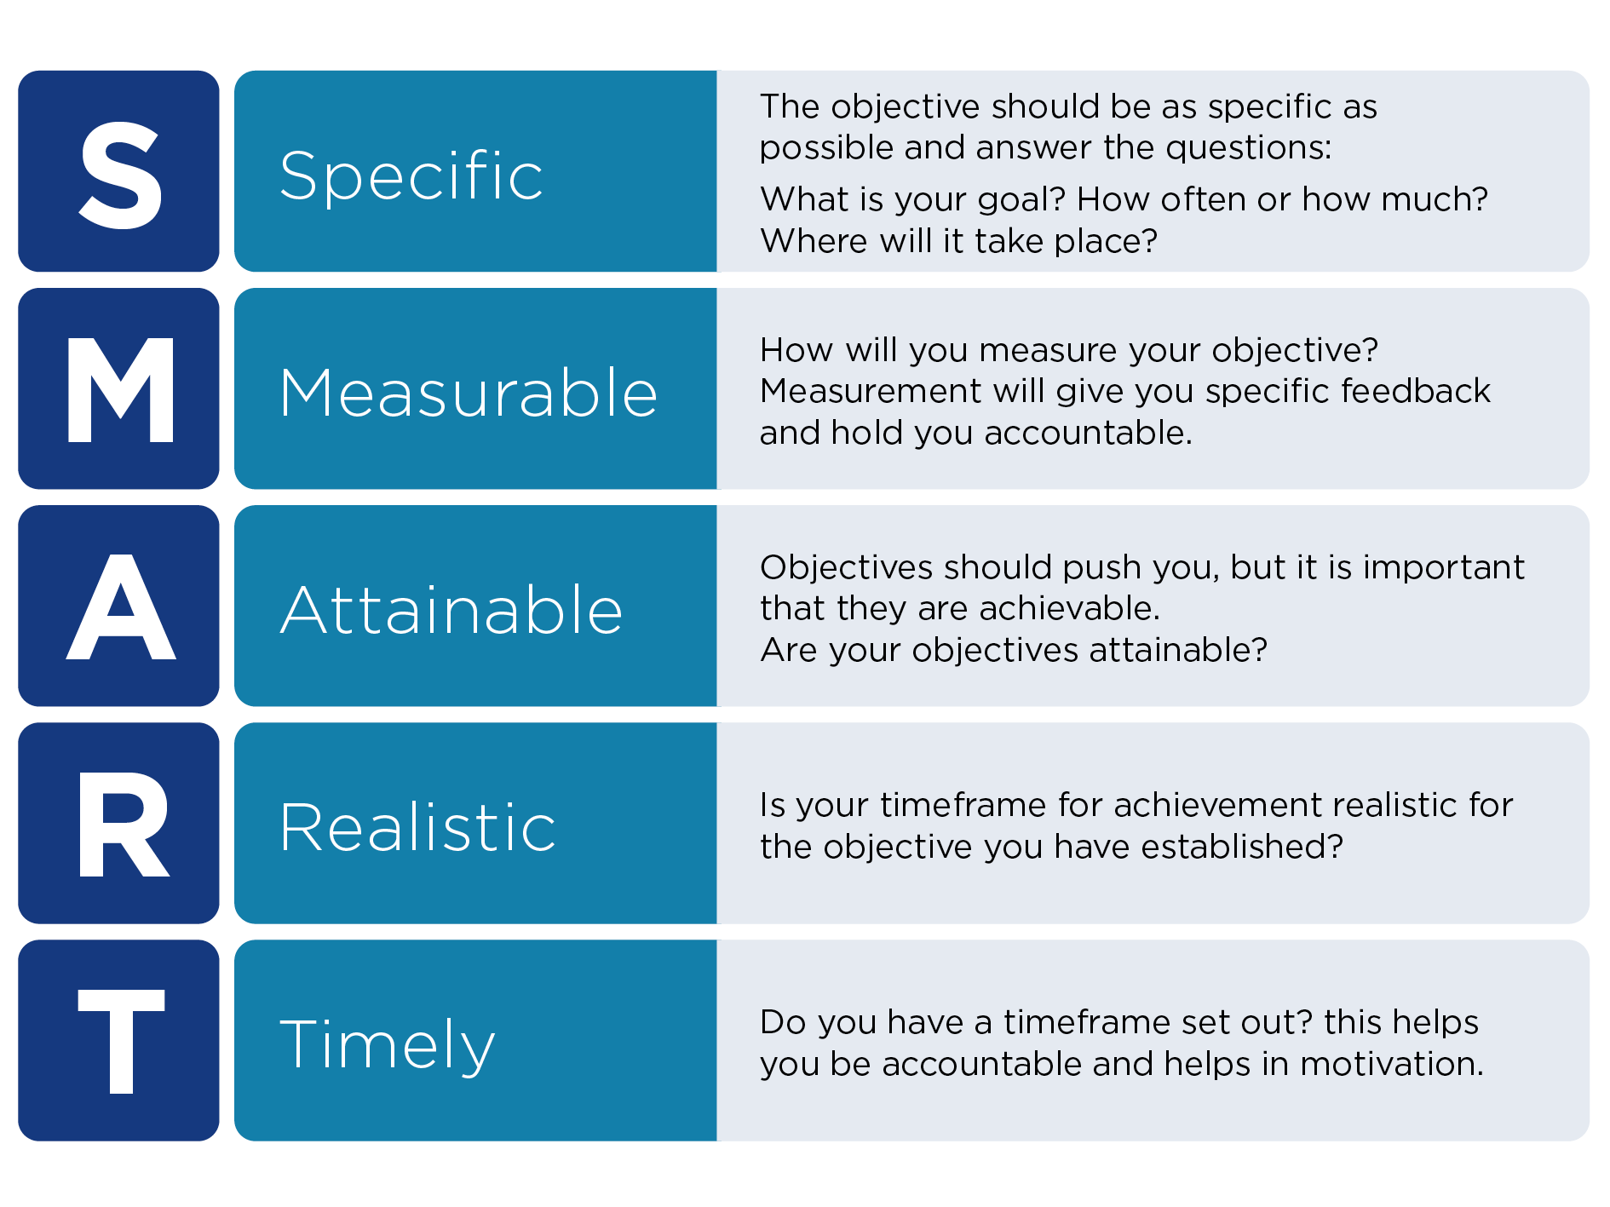

© State of New South Wales through Department of Planning, Industry and Environment 2020. The information contained in this publication is based on knowledge and understanding at the time of writing (March 2020). However, because of advances in knowledge, users are reminded of the need to ensure that the information upon which they rely is up to date and to check the currency of the information with the appropriate officer of the Department of Planning, Industry and Environment or the user’s independent adviser.

